Week 4

Phonetics & Phonology: ENG 250

Name____________________________ Surname ____________________________

A. Answer the following questions:

1. ***Which of the following words have a simple vowel (monophthong) and which have a complex vowel (diphthong)?***

(1) beach_____________

(2) fine_______________

(3) pound____________

(4) breeze____________

(5) boy_______________

(6) day_______________

(7) head______________

(8) young_____________

(9) through___________

(10) go_______________

1. ***Which word begins with a voiced consonant and which word begins with a voiceless consonant?***

(1) philosophy

(2) banana

(3) heartache

(4) pneumatic

(5) embargo

(6) knock

(7) charade

(8) Xerox

(9) write

(10) honest

1. ***Provide the place of articulation for the following consonants:***

[ p ] _____________________________ [ ɱ ] ____________________________________

[ j ] ______________________________ [ v ] ____________________________________

[ c ] ______________________________ [ x ] ____________________________________

[ ʎ ] _______________________________ [ ʃ ] ____________________________________

[ d ] _______________________________ [ ɹ ] ____________________________________

1. Describe the following co-articulatory phenomena; describe the change takes place in each case.

cat [kæt] + [s] → [kæts] **but** dog [dɒɡ] + [s] → [dɒɡz]

pet [pɛt] + [s] → [pɛts] **but**  gab [ɡæb] + [s] → [ɡæbz]

__________________________________________________________________________________________________________________________________________________________________________________________________________________________________________________________________________________________________________________________________________________________________________________________________________________________________________________________________

B. The following two figures show production of two consonantal sounds each. Identify the sounds and provide their phonetic description

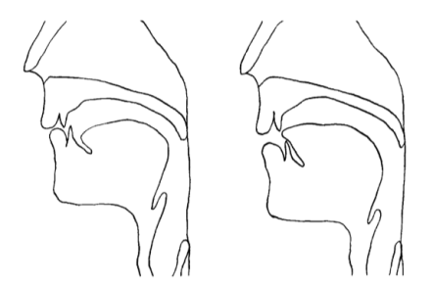

____________________________________________________________________________________________________________________________________________________________________________________________________________________________________________________________________________________________________________

C. Transcribe the following text :

*we were actually in America at the time*

*uh we’ll always remember the eleventh of September of course*

*we were staying with friends in San Francisco*

*we’d put our Jonathan*

*on a plane back to LA*

_____________________________________________________________________________________________________________________________________________________________________________________________________________________________________________________________________________________________________________________________________________________________________________________________________________________________________________________________________________________________________________________________________________